“Starting A New Program”
Sarah Pendergraft, BS SARAH.PENDERGRAFT@Mercy.Net
Mercy Fort Smith – Family Medicine Residency

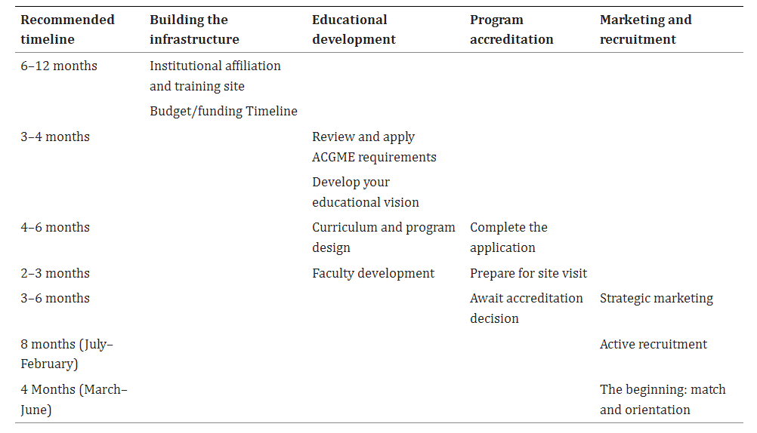
Family Medicine Residency Curriculum Resource:
Access Curriculum (fammedrcr.com)
-- STFM/AFMRD: This is worth the money to help a start up program with Curriculum!!!
Tips & Tricks:
- Make a binder with the entire application in it and review it to make sure you know it forward and backwards!
- Get as much done as humanly possible BEFORE residents arrive!
- Plan all 3 years in advance! (Plan every rotation: Talk with every potential preceptor, figure out if you are going to compensate them, etc)
- Write your policy book while you are waiting for review committee decision and go over it a million times so that nothing is left undone or confusing!
- Will your institution take VISAs? Figure this out EARLY!
- Know your institutions onboarding policy for residents, if there is not one, create one with the HR team!
- Market your FM clinic early for patient volume! Use your marketing team for help!
- Get New Innovations early and do all the training so you are ready to go!
- Schedule your PEC/CCC meetings NOW, plan the processes up front.

