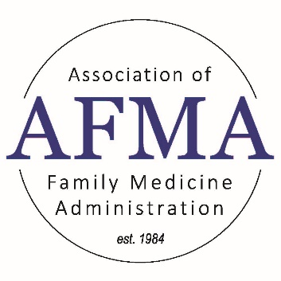

Resume to Reflect Leadership
Melissa Keller melissa.keller2@prismahealth.org

Components:
Name, Address, Email
LinkedIn URL
Professional Profiles Summary
Education
Experience
Previous Experience
Awards, Accomplishments, Presentations, Publications

Professional Profile Summary:
1. What are you really good at in GME?
2. What skills do you possess that make you a good leader in the field?
3. What are your plans going forward?

Sample Structure: Driven and enthusiastic _____ with experience in _____ and success in _____. Recognized for the ability to _______ and ______. Areas of expertise (or strengths) include _____, ______, and _____. *

Can be used as your “About” portion of LinkedIn!

Experience/Previous Experience:
What condition(s) have I improved while in this role?
What have I created while in this role?
What have I restructured?
Has our program grown? Added fellowships?
Has our program achieved accreditation?
Have we eliminated citations?
Who do I collaborate with and why?

Example:
BAD: Oversee residency program budget
BETTER: Develop and manage a $6.8 million budget in collaboration with Director of Finance

Tips:
Use strong action verbs (current tense if you’re doing it/past tense if you used to do it)
Use data when possible. How many applicants did you interview? How large is your budget?
Finish with a result, outcome, or benefit
Do not repeat accomplishment statements
3-5 accomplishment statements per experience
Only go back 10 years#
Highlight leadership and/or managerial experience
Use job descriptions!

www.afmaonline.org

11400 Tomahawk Creek Parkway
Leawood, KS 66211-2672

President
Pamela MacMillan
307-777-7911
pmac@uwyo.edu

President Elect
Membership Committee Chair
Hannah Ponder, BA, C-TAGME
hponder@yumaregional.org

Immediate Past President/Strategic
Planning/Nominating/Bylaws Chair
Summer Jamison, BS, MEd, C-TAGME
sdjamison@uams.edu

Co-Treasurers
Michelle Olivieri, BBA, C-TAGME
molivie@glfhc.org
Gina Silvey, C-TAGME
silveyg@health.missouri.edu

Education-Residency Administrative Development
(RAD) Workshop / Residency Leadership
Summit (RLS) Program Planning Co-Chairs
Melissa Keller, MS, MBA, C-TAGME
melissa.keller2@prismahealth.org
Emmalyn Dyer
emmalyn.dyer@nghs.com

Education-Audio & Web Conferencing Co-Chairs
Annette Sheets, C-TAGME
sheetsam@upmc.edu
Rebecca Webb
rebecca.webb@adventhealth.com

Mentoring Committee Co-Chairs
Michelle Olivieri, BBA, C-TAGME
molivie@glfhc.org
Diane Borgwardt, C-TAGME
diane.borgwardt@providence.org

Information Exchange-Website Co-Chairs
Secretary*
Deborah Egger, AAS, C-TAGME*
egger.deborah@mayo.edu
Shontay Patterson, MS, MHA
shontay.patterson@okstate.edu

Information Exchange-Media Chair
Gina Silvey, C-TAGME
silveyg@health.missouri.edu

Fundraising & Marketing Committee Co-Chairs
Lisa-Ann Roura, BS, C-TAGME
lisaann.roura@providence.org
Faye DeBard, MSHA, C-TAGME
faye.debard@providence.org

Executive Secretary
Cristin Estes
800-274-2237, ext. 6356
cestes@aafp.org

Physician Advisors
Diana Heiman, MD
Jennifer Knowles, MD
Hobart Lee, MD
Karen Mitchell, MD
Terri Nordin, MD
Steve Schultz, MD
Zachary Waterson, DO

