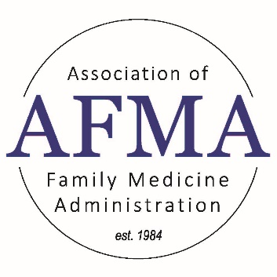

Virtual Interviews
Michelle Olivieri, BBA, C-TAGME
Lawrence Family Medicine Residency
Teaching Health Center
Sources:
https://www.aamc.org/about-us/mission-areas/medical-education/interviews-gme-where-do-we-go-here
Reasons to Do It:
- Cost-effective
  - Save money on meals
  - Save money on in-person events
  - Save applicants money
- Reduces bias
  - Allows applicants to interview that otherwise couldn’t afford to travel
Tips and Best Practices:
- Utilize Zoom or other virtual meeting software that allows use of breakout rooms
  - Controls time of each interview
  - Allows quick transition from one interview to another
  - Send 5-minute warning messages to breakout rooms
  - Have multiple co-hosts in case of computer crashes, call-outs, etc.
  - Incorporate zoom breaks to limit screen fatigue (i.e. 5-minutes after every 2-3 interviews, break to get lunch, etc).
  - Have lunchtime presentations to save time in the interview day (program overview, tours)
- Small pool of interviewers for consistent interview styles and assessments
  - Same residents/faculty interviewing consistently allows them to be more comfortable on Zoom, and standardize the interview process
- Add virtual tours to your interview day
  - Allows applicants to imagine themselves at your program and in your community
- Have multiple ways of access to residents and faculty
  - Q&A sessions with a resident before or after each interview session (opportunity to ask questions not able in interviews; casual atmosphere)
  - Virtual social events and second looks

www.afmaonline.org

11400 Tomahawk Creek Parkway
Leawood, KS 66211-2672

President
Pamela MacMillan
307-777-7911
pmac@uwyo.edu

President Elect
Membership Committee Chair
Hannah Ponder, BA, C-TAGME
hponder@yumaregional.org

Immediate Past President/Strategic
Planning/Nominating/Bylaws Chair
Summer Jamison, BS, MEd, C-TAGME
sdjamison@uams.edu

Co-Treasurers
Michelle Olivieri, BBA, C-TAGME
molivie@glfhc.org
Gina Silvey, C-TAGME
silveyg@health.missouri.edu

Education-Residency Administrative Development
(RAD) Workshop / Residency Leadership
Summit (RLS) Program Planning Co-Chairs
Melissa Keller, MS, MBA, C-TAGME
melissa.kelle2@prismahealth.org
Emmalyn Dyer
emmalyn.dyer@nghs.com

Education-Audio & Web Conferencing Co-Chairs
Annette Sheets, C-TAGME
sheetsam@upmc.edu
Rebecca Webb
rebecca.webb@adventhealth.com

Mentoring Committee Co-Chairs
Michelle Olivieri, BBA, C-TAGME
molivie@glfhc.org
Diane Borgwardt, C-TAGME
diane.borgwardt@providence.org

Information Exchange-Website Co-Chairs
Secretary*
Deborah Egger, AAS, C-TAGME*
egger.deborah@mayo.edu
Shontay Patterson, MS, MHA
shontay.patterson@okstate.edu

Information Exchange-Media Chair
Gina Silvey, C-TAGME
silveyg@health.missouri.edu

Fundraising & Marketing Committee Co-Chairs
Lisa-Ann Roura, BS, C-TAGME
lisaann.roura@providence.org
Faye DeBard, MSHA, C-TAGME
faye.debard@providence.org

Executive Secretary
Cristin Estes
800-274-2237, ext. 6356
cestes@aafp.org

Physician Advisors
Diana Heiman, MD
Jennifer Knowles, MD
Hobart Lee, MD
Karen Mitchell, MD
Terri Nordin, MD
Steve Schultz, MD
Zachary Waterson, DO

