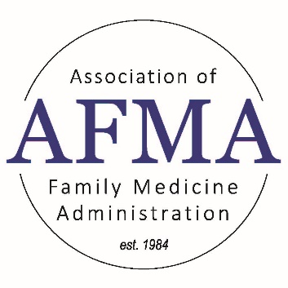
Topic: Program Evaluation Committee
Facilitator Name: Victoria Gallagher
Facilitator Email: vgallagher@colquittregional.com

Please provide 3 learning objectives for the topic
Objective 1: Describe the role of PEC in ACME requirements, strategic planning, and program activities.
Objective 2: Understand the role of each PEC member.
Objective 3: Identify best practices of highly functioning PECs.

Important Information:
Set up a meeting schedule.
Evaluate who should be on the Committee.
Evaluate the APE each year. Were the results fruitful?
Ensure the committee has access to the most up-to-date data and information.

Helpful links:
https://www.acgme.org/globalassets/PDFs/commonguide/VC_Evaluation_ProgramEvaluation_Explanation.pdf
https://www.mededportal.org/doi/10.15766/mep_2374-8265.11039
HCPRO: The Program Evaluation Committee Handbook: From Annual Program Evaluation to Self-Study

www.afmaonline.org

11400 Tomahawk Creek Parkway
Leawood, KS 66211-2672

President
Pamela MacMillan
307-777-7911
pmac@uwyo.edu

President Elect
Membership Committee Chair
Hannah Ponder, BA, C-TAGME
hponder@yumaregional.org

Immediate Past President/Strategic
Planning/Nominating/Bylaws Chair
Summer Jamison, BS, MEd, C-TAGME
sdjamison@uams.edu

Co-Treasurers
Michelle Olivieri, BBA, C-TAGME
molivie@glfhc.org
Gina Silvey, C-TAGME
silveyg@health.missouri.edu

Education-Residency Administrative Development
(RAD) Workshop / Residency Leadership
Summit (RLS) Program Planning Co-Chairs
Melissa Keller, MS, MBA, C-TAGME
melissa.keller@ketteringhealth.org
Emmalyn Dyer
emmalyn.dyer@nghs.com

Education-Audio & Web Conferencing Co-Chairs
Annette Sheets, C-TAGME
sheetsam@upmc.edu
Rebecca Webb
rebecca.webb@adventhealth.com

Mentoring Committee Co-Chairs
Michelle Olivieri, BBA, C-TAGME
molivie@glfhc.org
Diane Borgwardt, C-TAGME
diane.borgwardt@providence.org

Information Exchange-Website Co-Chairs
Secretary*
Deborah Egger, AAS, C-TAGME*
egger.deborah@mayo.edu
Shontay Patterson, MS, MHA
shontay.patterson@okstate.edu

Information Exchange-Media Chair
Gina Silvey, C-TAGME
silveyg@health.missouri.edu

Fundraising & Marketing Committee Co-Chairs
Lisa-Ann Roura, BS, C-TAGME
lisaann.roura@providence.org
Faye DeBard, MSHA, C-TAGME
faye.debard@providence.org

Executive Secretary
Cristin Estes
800-274-2237, ext. 6356
cestes@aafp.org

Physician Advisors
Diana Heiman, MD
Jennifer Knowles, MD
Hobart Lee, MD
Karen Mitchell, MD
Terri Nordin, MD
Steve Schultz, MD
Zachary Waterson, DO

