RPS CONSULTANT LIST
 | lake@utmck.edu
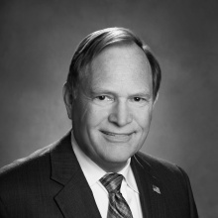 | Greg Blake, MD, MPH, FAAFP  ghblake@utmck.edu  Dr. Blake is a professor in the Department of Family Medicine at the University of Tennessee Graduate School of Medicine in Knoxville. He served as department chairman and chief of family medicine at the University of Tennessee Medical Center. Dr. Blake has served as an RPS consultant since 1994. Dr. Blake completed his medical education at the University of Texas Southwestern Medical School and completed his family medicine residency at Dwight David Eisenhower Army Medical Center at Fort Gordon, Georgia. He received a Master of Public Health degree from the University of Oklahoma in Oklahoma City.
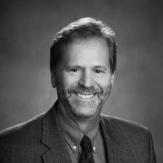 | Steven Crane, MD, MA, FAAFP  steven.crane@mahec.net  Dr. Crane is a professor in the Department of Family Medicine at the University of North Carolina at Chapel Hill. He serves as an advisor for HRSA grantees in rural residency program development. He joined the RPS Panel of Consultants in 2012. Dr. Crane trained as a health economist at Stanford University and worked at the Institute of Medicine and the Congressional Budget Office in Washington, DC, as a health policy analyst. He completed his medical education at Case Western Reserve University in Cleveland and completed his family medicine residency at the University of Missouri-Columbia where he served as chief resident.
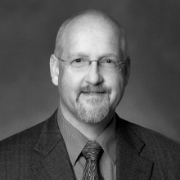 | Roger Garvin, MD, FAAFP  garvinr@ohsu.edu  For 12 years, Dr. Garvin served as the Family Medicine Residency Director at Oregon Health & Science University in Portland. He joined the RPS Panel of Consultants in 2015. Dr. Garvin received his medical degree from Oregon Health & Science University. He completed his residency at Family Medicine Spokane and practiced eight years of full spectrum care in a small town in Eastern Washington. He then spent 11 years on the faculty of the Spokane Family Medicine residency and completed a faculty development fellowship at the University of Washington.

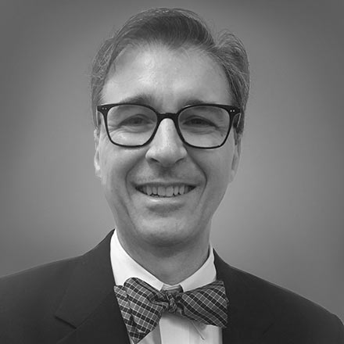 | John Gazewood, MD  jdg3k@virginia.edu  Dr. Gazewood has been the residency program director for the University of Virginia Family Medicine Residency Program since 2006. Previously he served as the school of medicine's course director, predoctoral program director for the family medicine department, and medical director for the Family Medicine Center. Dr. Gazewood received his medical degree from Vanderbilt University, and finished residency training at the University of Missouri-Columbia. He practiced full-scope Family Medicine in Madisonville, TN for 5 years before returning to the University of Missouri where he completed a faculty development and geriatrics fellowship.
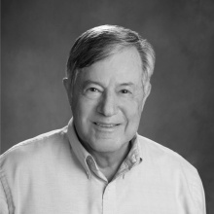 | Bill Gillanders, MD, FAAFP  dwrg11@gmail.com  Dr. Gillanders directed the Providence Oregon Family Medicine Residency Program in Milwaukie, Oregon, until 2013. He directed successful residency programs in Ohio, California, and Oregon. He has served on the RPS Panel of Consultants for more than 20 years. Dr. Gillanders received his medical degree from the University of California at San Francisco. He completed his residency at the University of Washington and practiced for 10 years in White Salmon, Washington, before pursuing an academic career.
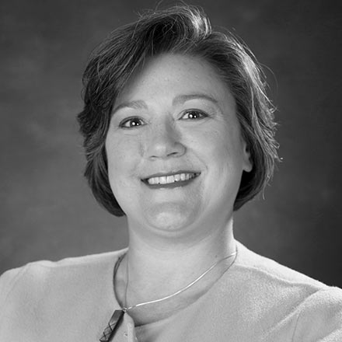 | Diana Heiman, MD, CAQSM  dianalheiman@gmail.com  Dr. Heiman is the Vice Chair for Academic and Faculty Affairs in the University of Kentucky Department of Family and Community Medicine. Prior to that she was the Assistant Dean for GME for the Quillen College of Medicine at East Tennessee State University and the Department of Family Medicine GME Liaison. Dr. Heiman initially joined the faculty at the University of Connecticut/St. Francis Hospital Family Medicine Residency as the Associate Residency Director and Associate Sports Medicine Fellowship Director from 2003-2011. She then became the program director at the Johnson City Family Medicine Residency Program in January 2012 until June 2019. Dr. Heiman received her medical degree from Case Western Reserve University, and then completed residency in Family Medicine at the University of Virginia. She then completed her Primary Care Sports Medicine Fellowship at the University of Michigan, where she stayed as junior faculty. She joined RPS in 2019.
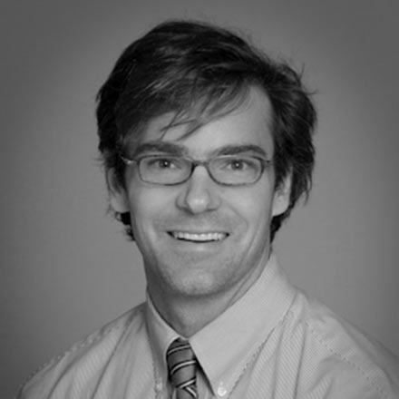 | Bryan Hodge, DO  bhodge@brchs.com  Dr. Hodge is the director of the Rural Health Initiatives for MAHEC in western North Carolina. He is the former program director of Hendersonville Rural Family Medicine Residency Program and the founding program director of the Boone Family Medicine Residency Program. As an Assistant Clinical Professor with the University of North Carolina Department of Family Medicine, he has dedicated his career to using innovative models to improve, expand, and build residency training opportunities leading to better health outcomes in areas of high need. Dr. Hodge received his degree from the AT Still University Kirksville College of Osteopathic Medicine in Missouri.
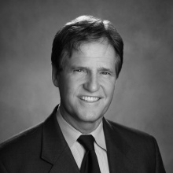 | Walt Mills, MD, MMM, FACPE, FAAFP  millsw@natividad.com  Dr. Mills is clinical professor in the Department of Family and Community Medicine at the University of California, San Francisco, and has been on the clinical faculty since 1986. He is the designated institution official and director of medical education and medical student program and associate director for the UCSF Natividad Family Medicine Residency Program in Monterey County, California. Dr. Mills is president-elect for the California Academy of Family Physicians. He joined the RPS Panel of Consultants in 2012.
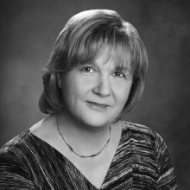 | Elissa Palmer, MD, FAAFP  elissa.palmer@unlv.edu  Dr. Palmer has worked in private practice at Central Maine Clinical Associates and Stowe (Vermont) Family Practice. She also has served as program director of the Altoona Family Physicians Residency in Pennsylvania. Dr. Palmer is professor and chair of family medicine at the University of Nevada School of Medicine in Las Vegas. Dr. Palmer joined the Panel of Consultants in 2015. Dr. Palmer attended medical school at Johns Hopkins University School of Medicine. She completed her residency at the University of Wisconsin, St. Mary’s Hospital Family Medicine residency.
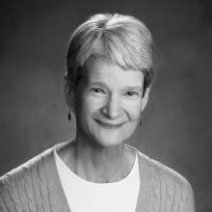 | Judy Pauwels, MD, FAAFP  jpauwels@uw.edu  Dr. Pauwels is a family physician and professor at the University of Washington (UW) in Seattle. She was program director at the UW Family Medicine residency program for 10 years, after being at Tacoma Family Medicine for six years. She currently works in the UW WWAMI Network as the developing program consultant, organizes regional faculty development, and provides program and institutional support services. She has worked with HRSA as a consultant on the Teaching Health Center grant program and served on STFM and FMAH task forces. She currently serves as an advisor for HRSA grantees in rural residency program development. Dr. Pauwels has served on the RPS Panel of Consultants since 2002.
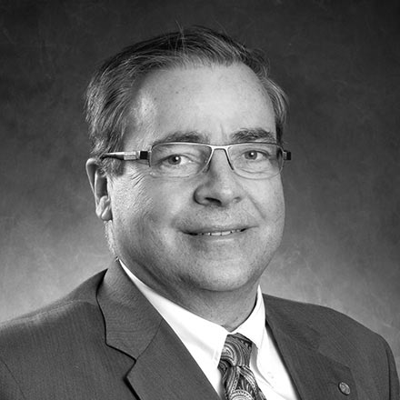 | Randy Pearson, MD, FAAFP, FACSM  pearson@msu.edu  Dr. Pearson is the senior associate director and sports medicine fellowship director at the Sparrow/MSU Family Medicine Residency. He is also the current Associate Dean for Graduate Medical Education and DIO for the MSU College of Human Medicine and a professor in the Department of Family Medicine. Previously, he served as program director for the MSU/St. Lawrence Family Practice Residency, during which time, the hospital and residency underwent a merger. After residency, Dr. Pearson worked in private practice. He later completed a faculty development fellowship through the MSU Office of Medical Education, Research and Development. He completed his medical education at Wayne State University School of Medicine and completed residency training at the Michigan State University/St. Lawrence Family Practice Residency, where he served as chief resident in his third year. Dr. Pearson has served as an RPS consultant since 2019.
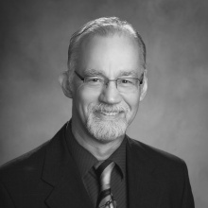 | Louis Sanner, MD, MSPH, FAAFP  lou.sanner@fammed.wisc.edu  Dr. Sanner is a practicing physician and faculty member at the University of Wisconsin Department of Family Medicine and Community Health in Madison, where he also served as program director from 1996-2002. Dr. Sanner has expertise in GME financing and rural program development. He has provided advanced obstetrical training to local health care providers in various parts of the developing world. Dr. Sanner has served on the Panel of Consultants since 2001. Dr. Sanner attended Stanford Medical School. He completed his Family Medicine residency, chief residency, and two-year research fellowship at the University of Missouri-Columbia.
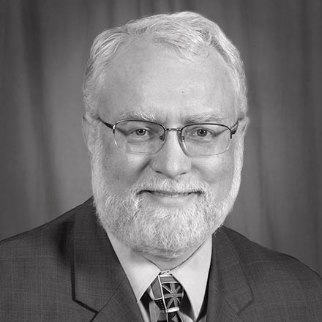 | Stephen Schultz, MD, FAAFP  Stephen_schultz@urmc.rochester.edu  Dr. Schultz is the program director at the University of Rochester Family Medicine Residency Program. Prior to this role, he served for five years with National Health Service Corps at an inner-city community health center. Dr. Schultz has served as a family medicine residency consultant in Iran, Japan, and Russia. He served 4 years on the Board of Directors of the Association of Family Medicine Residency Directors. Dr. Schultz received his medical degree from Brown in 1992. He completed his family medicine residency at the University of Rochester/Highland Hospital family medicine residency program, and served a fourth year as chief resident.
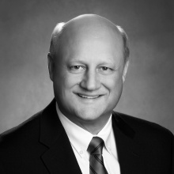 | Kent Voorhees, MD, FAAFP  kent.voorhees@ucdenver.edu  Dr. Voorhees is professor of clinical practice and vice chair for education for the Department of Family Medicine at the University of Colorado School of Medicine. He oversees all the department’s educational programs including family medicine residencies, fellowships which include sports medicine, palliative medicine and addiction medicine, and medical student education. He helped develop a rural training track and started a family medicine residency in 1994 from his private practice, serving as the program director. He has expertise in GME financing, advocacy, and rural program development. Dr. Voorhees has served on the RPS Panel of Consultants since 2010.
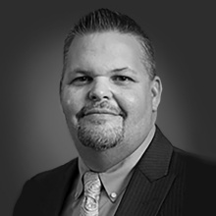 | Zach Waterson, DO, FAAFP  zwaterson@fwmep.edu  Dr. Waterson joined the faculty of FWMEP in 2003 as director of Osteopathic Medical Education. In 2010, he returned to FWMEP full time as associate program director. He has served as program director since 2013 and was promoted to DIO. Dr. Waterson joined the Panel of Consultants in 2016. Dr. Waterson received his medical degree from the University of Health Sciences College of Osteopathic Medicine in Kansas City, Missouri. He completed his residency at the Fort Wayne (Indiana) Medical Education Program (FWMEP), serving as chief resident during his third year.
RPS STAFF

Deanne St. George  GME Manager  American Academy of Family Physicians  11400 Tomahawk Creek Parkway  Leawood, KS 66211  800.274.2237 x6738  dstgeorge@aafp.org | 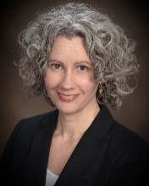
Kimberly Sixkiller  RPS Manager  American Academy of Family Physicians  11400 Tomahawk Creek Parkway  Leawood, KS 66211  800.274.2237 x6706  ksixkiller@aafp.org | 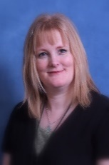
Margot Savoy, MD, MPH, FAAFP  Senior Vice President for Education  American Academy of Family Physicians  11400 Tomahawk Creek Parkway  Leawood, KS 66211  800.274.2237 x6360 | 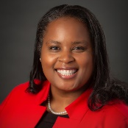
Karen B. Mitchell, MD  Medical Education Division Director  American Academy of Family Physicians  11400 Tomahawk Creek Parkway  Leawood, KS 66211  800.274.2237 x6750  kmitchell@aafp.org | 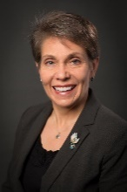
Ashley Herman, BSOL  Administrative Coordinator, GME  Medical Education Division Director  American Academy of Family Physicians  11400 Tomahawk Creek Parkway  Leawood, KS 66211  800.274.2237 x6164  aherman@aafp.org | 